1. **INSTALL NGINX AND RUN NGINX ON PORT NUMBER 81**.

* 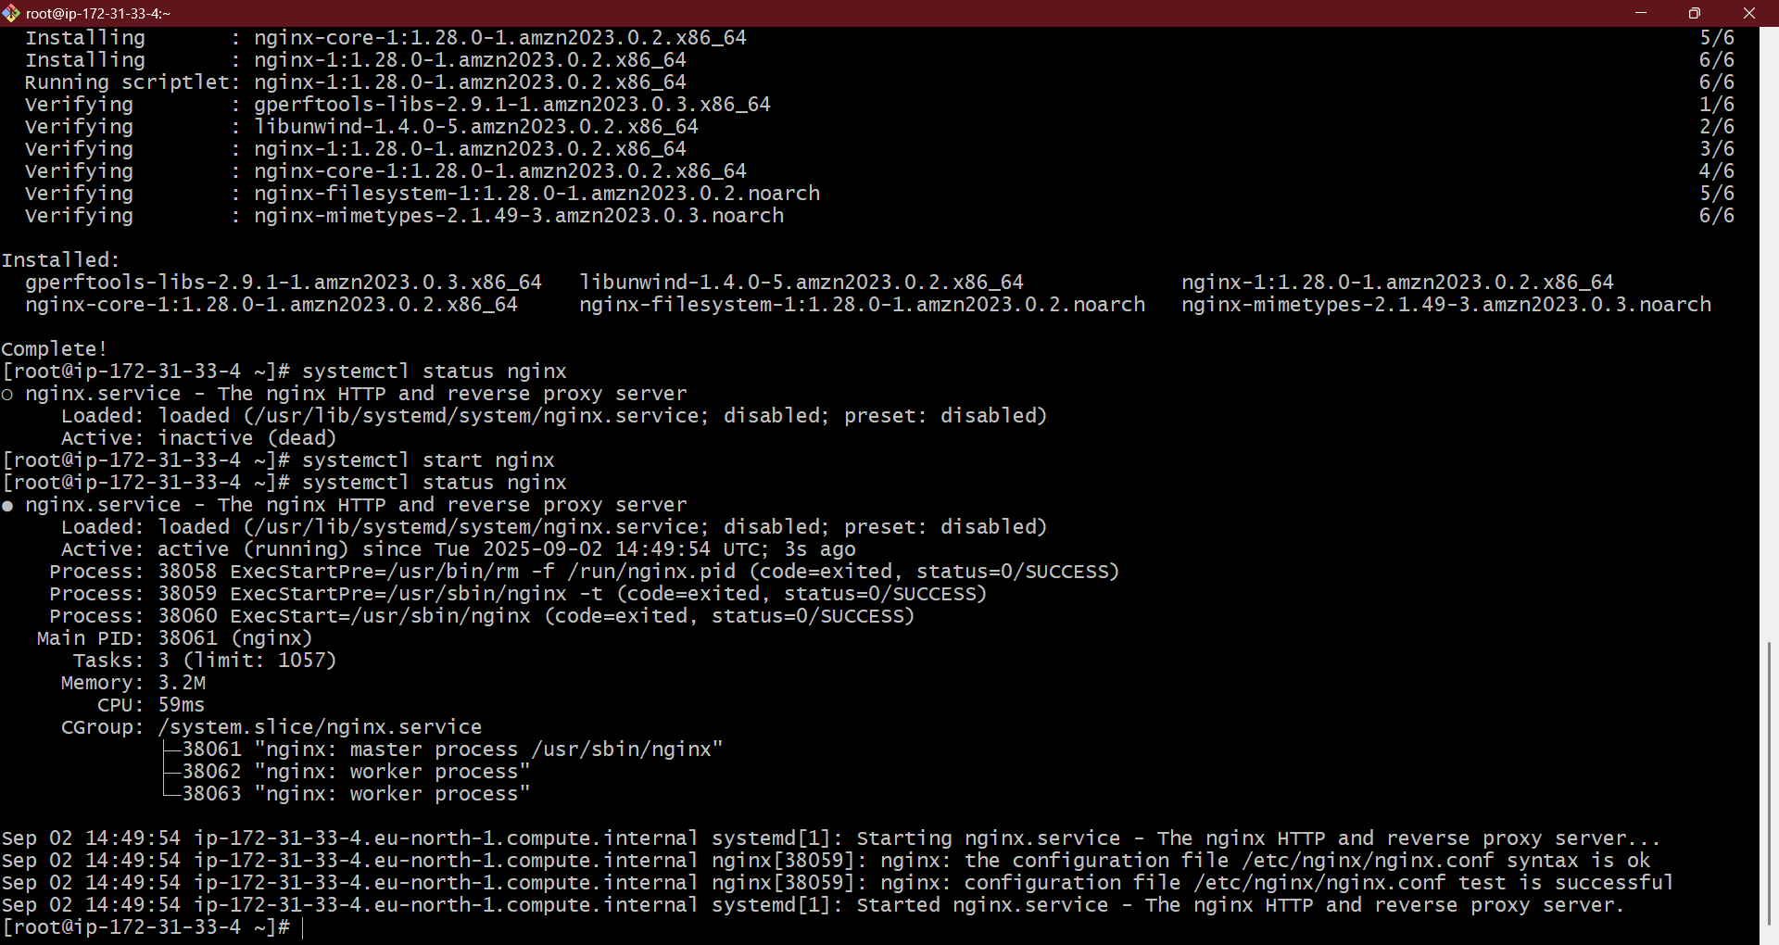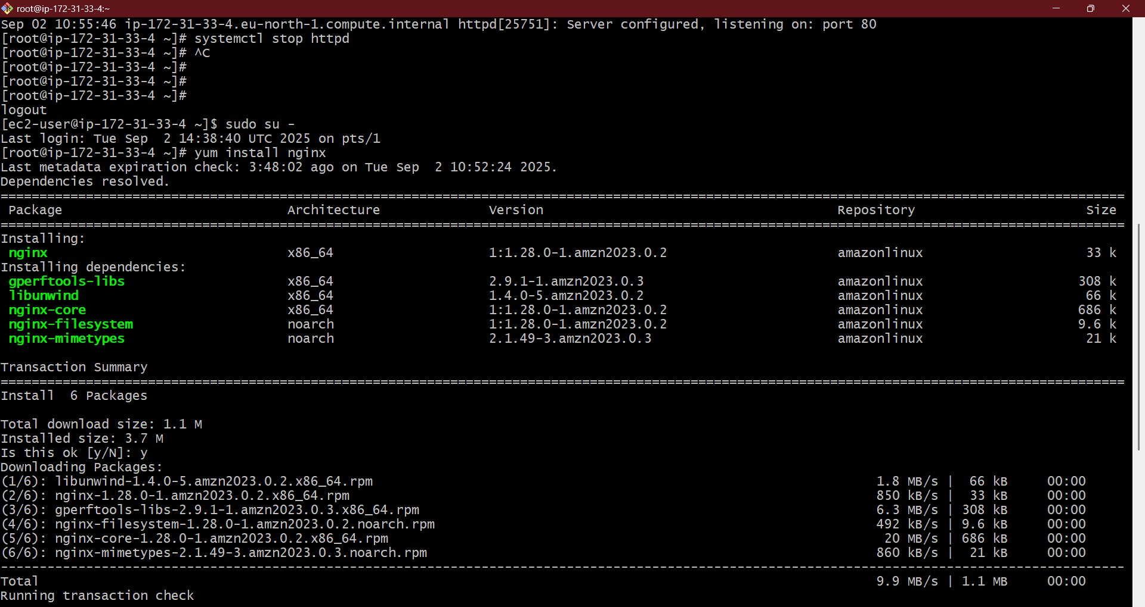install nginx service in linux machine : yum install nginx
* start the nginx service : systemctl start nginx

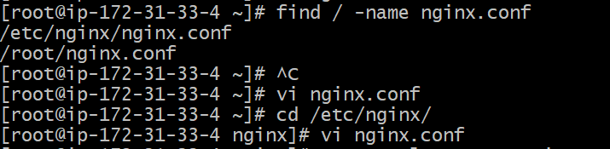

* find the file : file / -name nginx.conf
* go to the directory : cd /etc/nginx/
* view the file contents : vi nginx.conf
* 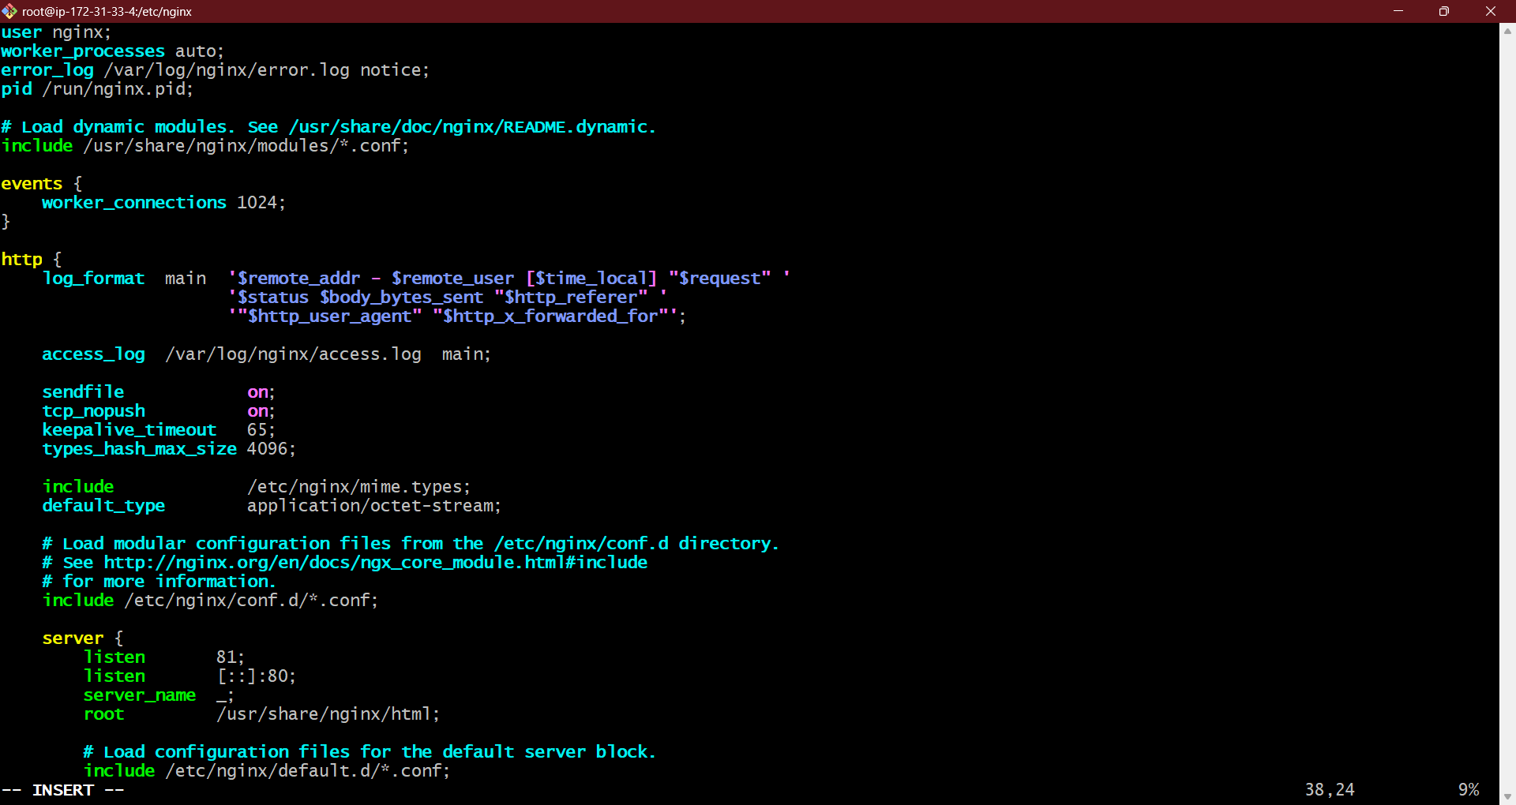in nginx.conf change : LISTEN 80 to 81 by using ‘i’ – insert
* Enter : esc :wq! – to save and exit the file

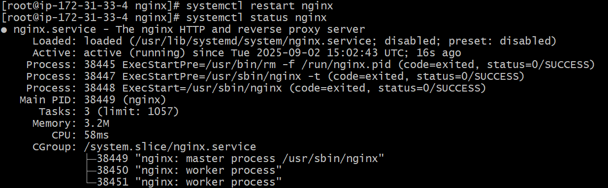

* Restart the service : systemctl restart nginx

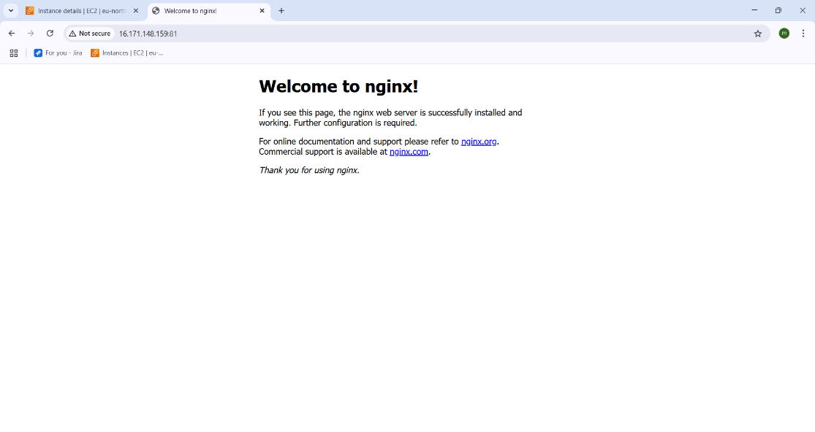

* Now got o web and enter the – “ipv 4 publicadress: 81” (note : you can get the ip v4 adress in aws instance that you have launched before)
* You can see the nginx is running in port 81.

1. **. DEPLOYING THE SAMPLE HTML FILE IN NGINX PORT 82**

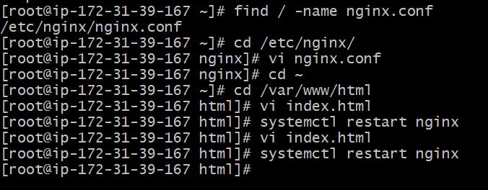

* Go to the html directory : cd /var/www/html/
* View the file : vi index.html

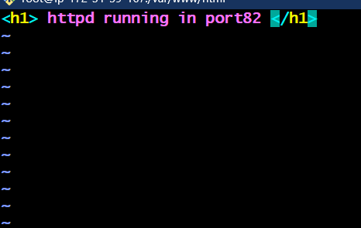

* Enter the text or content you want o view on web page .
* Save by entering esc button and enter :wq! – to save and exit



* Restart the service – systemctl restart nginx

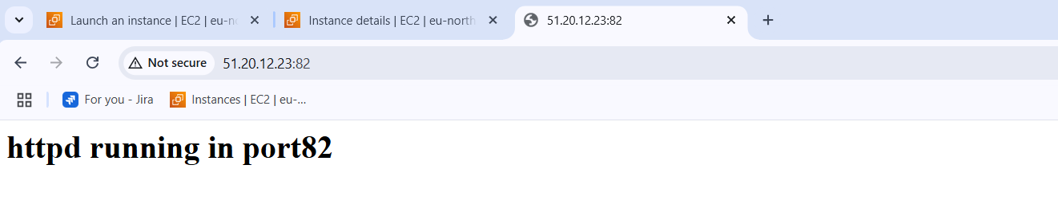

* Got to the web BROWSER and enter “ipv 4 publicadress: 81”
* You see the deployed html file is reflecting in the web page.

1. **HOW TO INSTALL AND RUN HTTPD IN PORT 82**

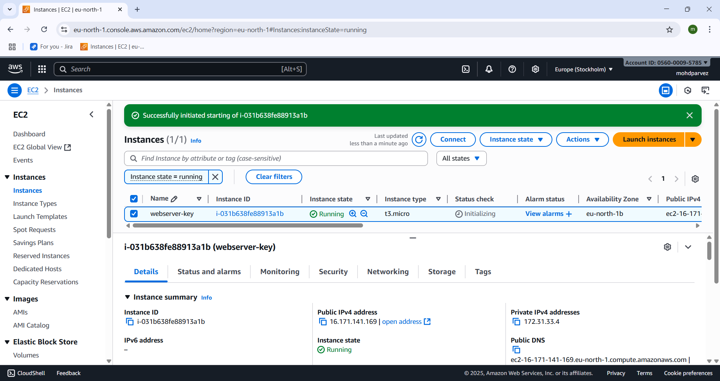

* Lauch aws ec2 instance .

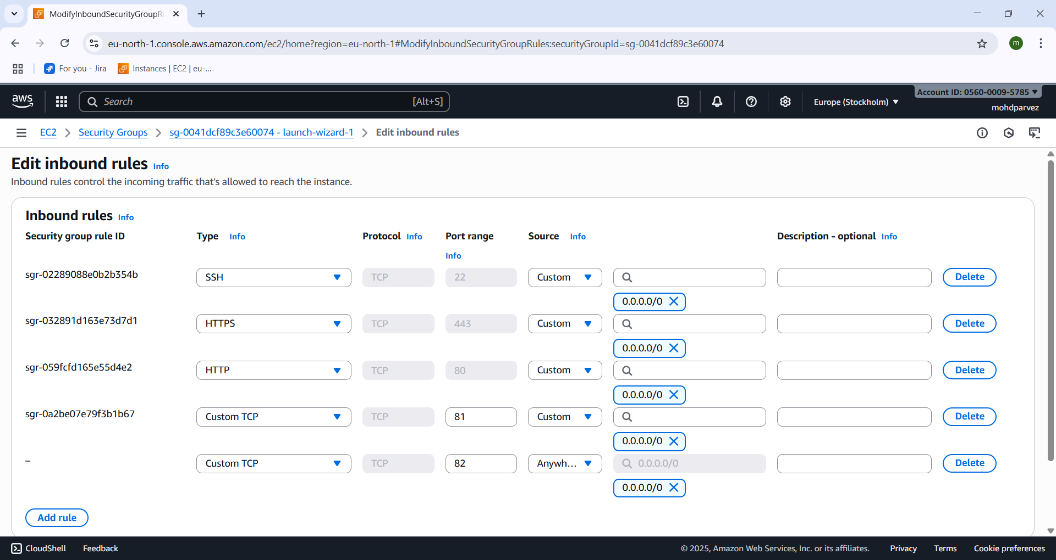

* Go to security groups and click on edit inbound rules
* Add security group with custom tcp and give port no 82 and save.

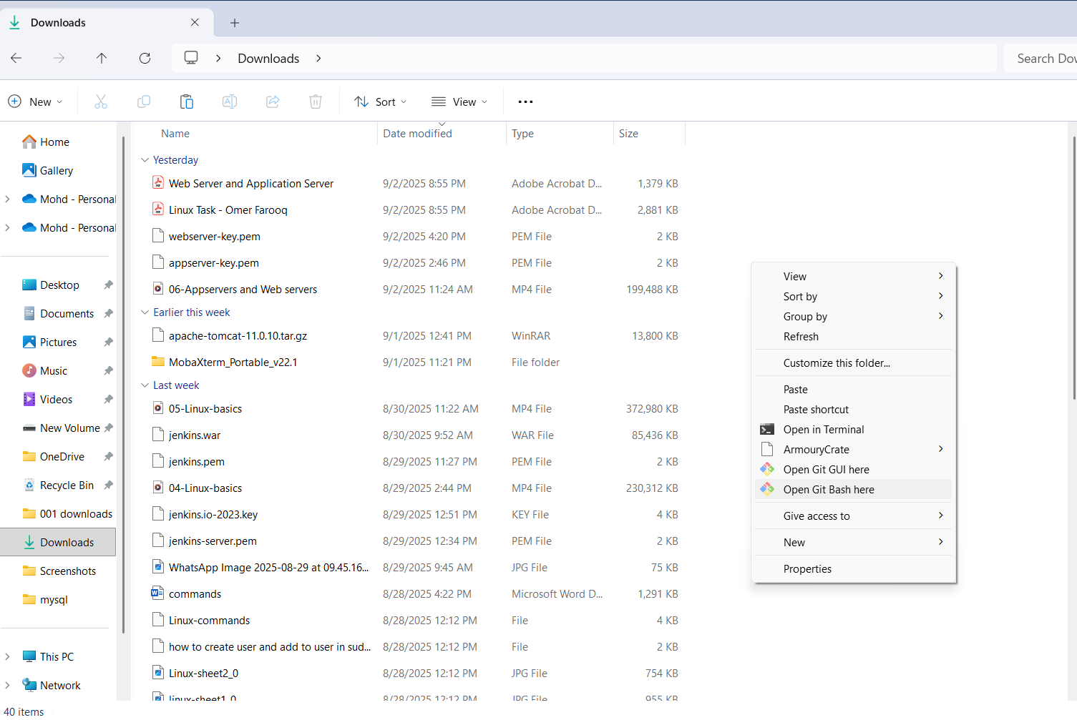

* Go to the location where keypar.pem is downloaded and right click and select open git bash here.

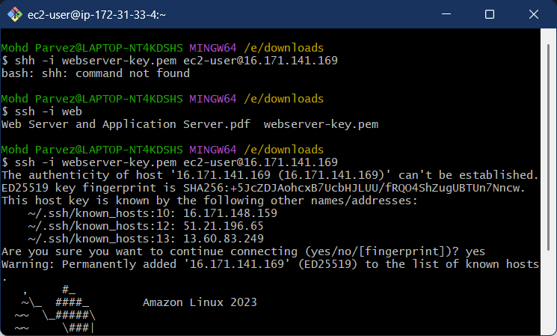

* Connect to the remote machine by using : ssh -i “keypair.pem” ec2-user@ “ip_v4 _public address”.

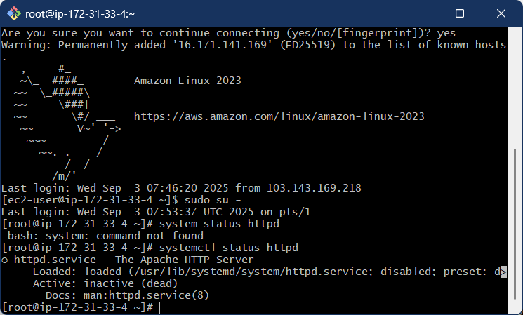

* Install the httpd (apache ) service : yum install httpd
* Check the status of httpd (apache) : systemctl status httpd

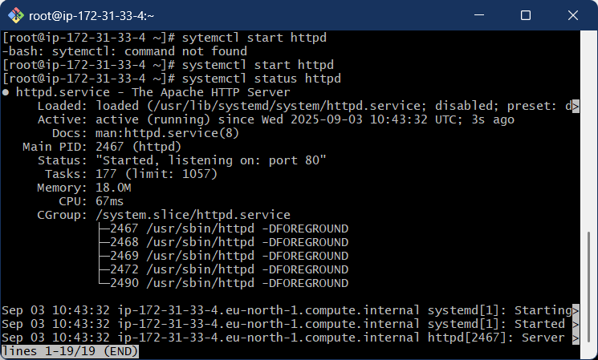

* Start the service if it is inactive : systemctl start httpd

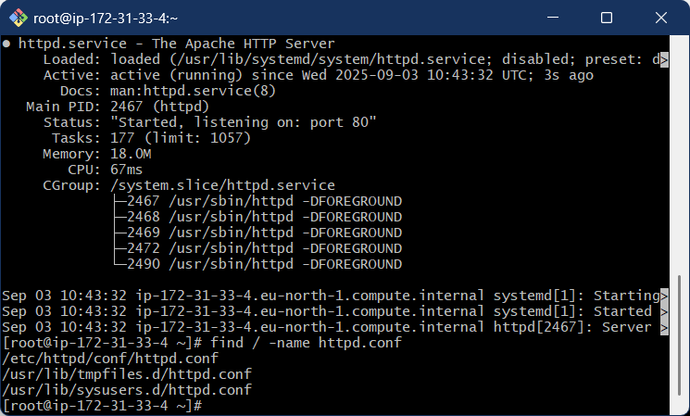

* Find the configuration file using : find / -name httpd.conf
* Go to the directory where the httpd. Conf file is located using cd command

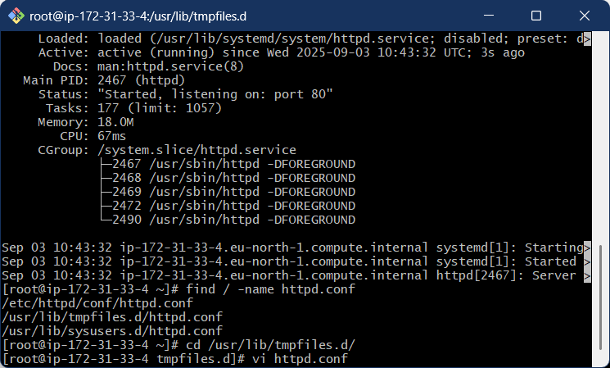

* Cd /usr/lib/tmpfiles.d/ : going ton the directory where the httpd.conf file is present
* See the content in the file : vi “filename”.conf

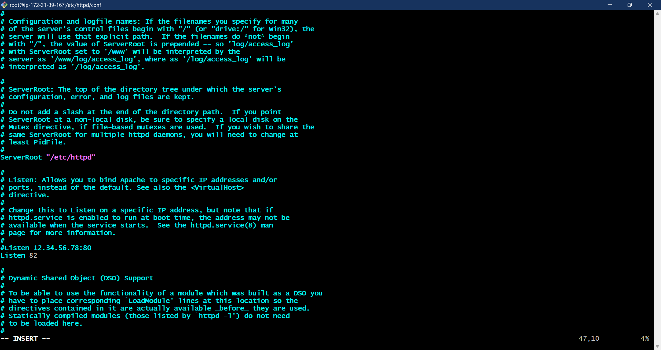

* After entering in to file look LISTEN 80 and the change 80 to 82 by using “i” command
* Save it by entering esc button :wq!
* Run command : systemctl restart httpd

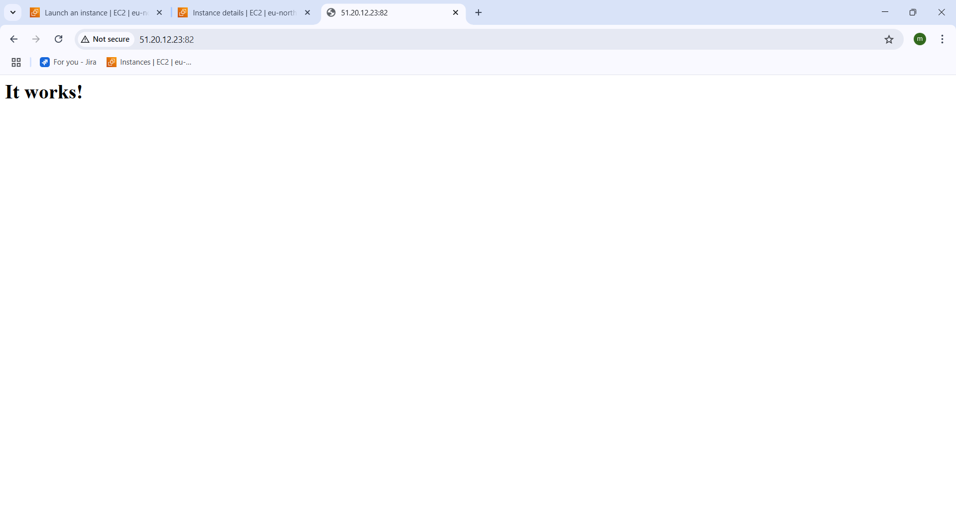

* Copy the ipv4 adress and enter : “ipv4 public address” :82
* You can see the the httpd is running on port 82.

1. **Deploying sample index.html on httpd:**

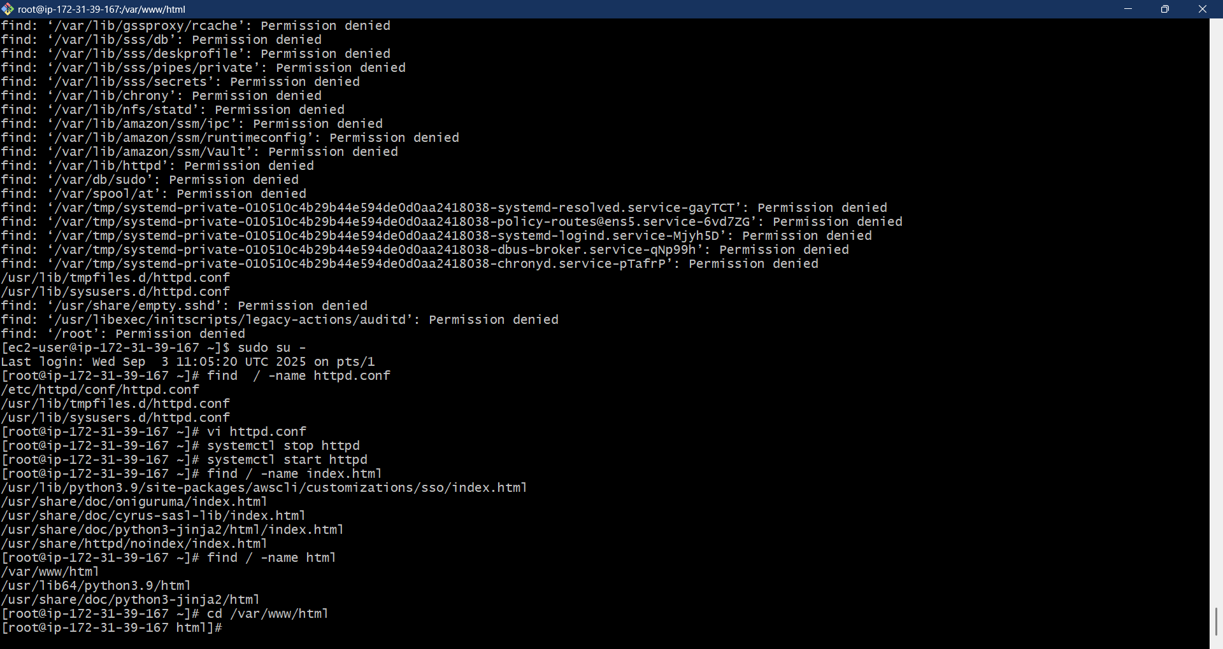

* Go to the html directory where the index.html file is present
* Cd /var/www/html



* Enter : vi index.html – to vie the file contents



* In the file enter the out put you want
* And save it by entering esc button :wq!



* Systemctl restart httpd



* ENTER : AWS ipv4 adress and enter port : “ipv4 public address” :82
* You can see the page with the index.html I have provided.

1. **APACHE TOMCAT ON PORT NUMBER 8082**



* Lauch aws ec2 instance .

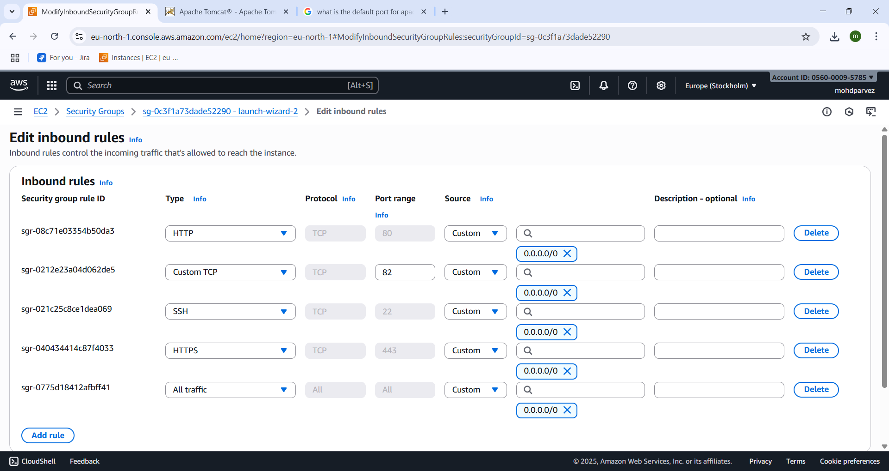

* Go to security groups and click on edit inbound rules
* Add security group with custom tcp and give port no all and save.



* Go to the location where keypar.pem is downloaded and right click and select open git bash here.



* Connect to the remote machine by using : ssh -i “keypair.pem” ec2-user@ “ip_v4 _public address”.



* Here you can see the aws ec2 remote machine has been connected .
* Switch to root user to not get any issues regarding the permission: sudo su –

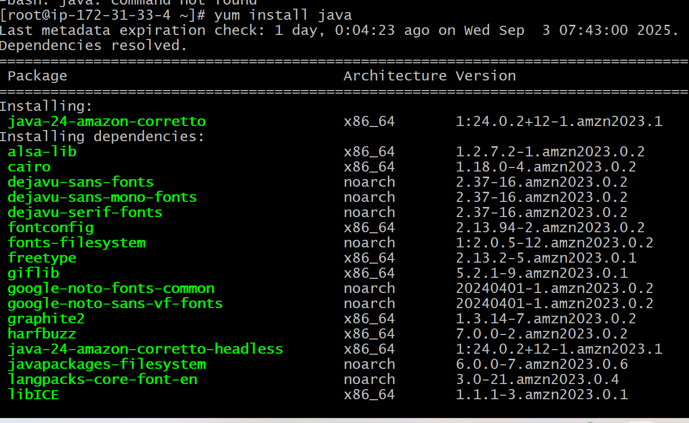

* Install java because the java is the soure or language that is used for tomcat is creted using java script or language
* Yum install java.

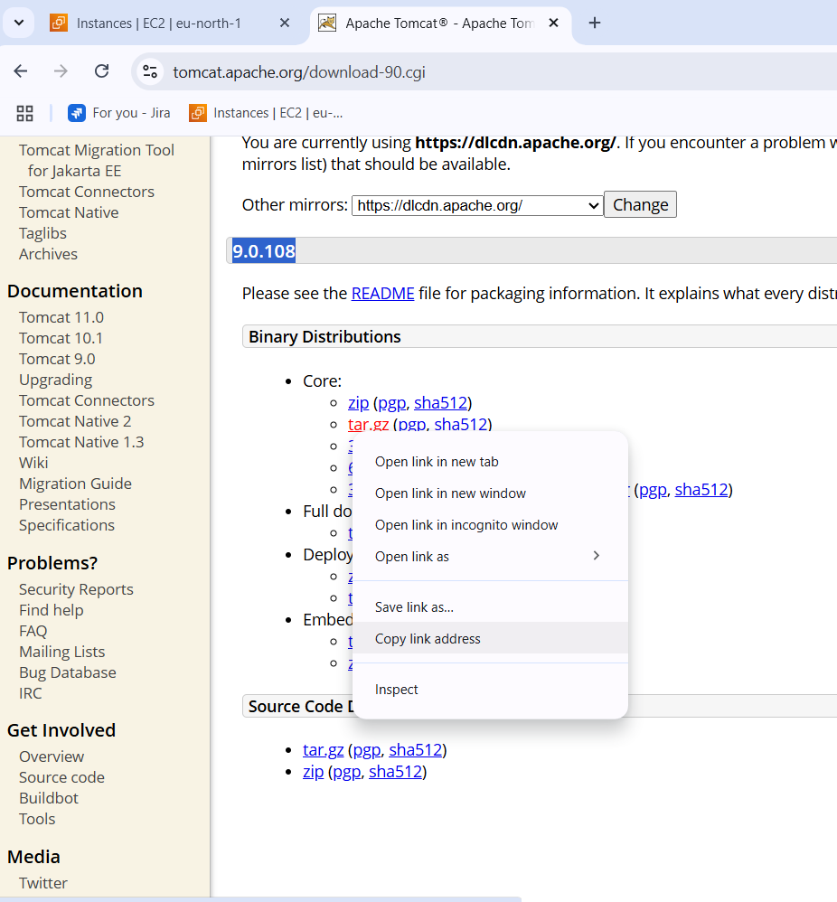

* Every aaplication is cannot be installed by “yum”
* Go to google and search for apache tomcat download select version copy the link of the download file that is zip or tar.

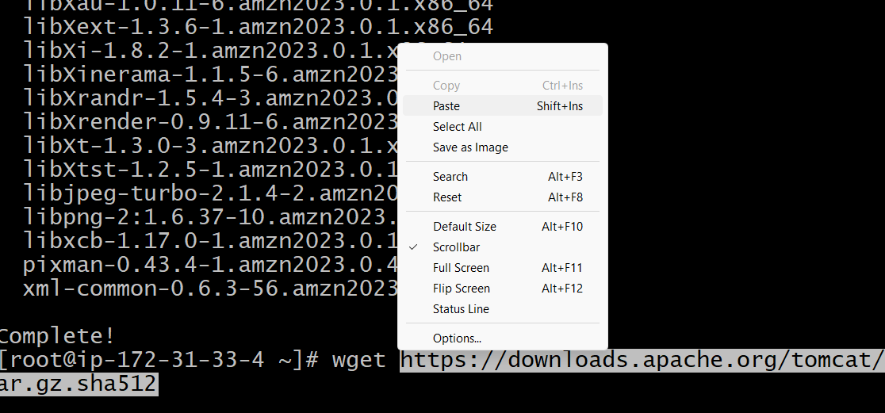

* Enter wget “url” that uou cpied and enter to download the tomcat.
* 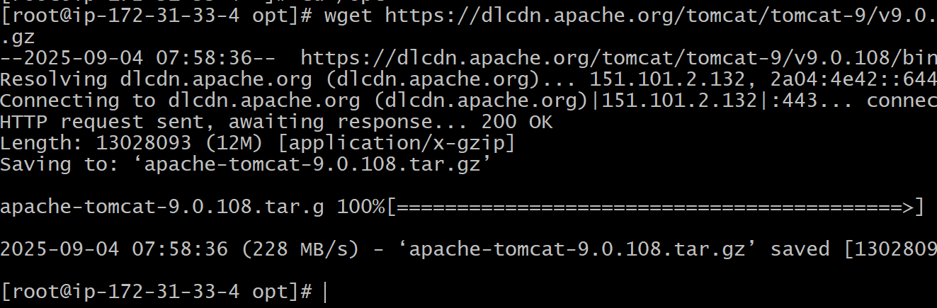here you can see the file has been downloaded.
* Now you need to extract the file

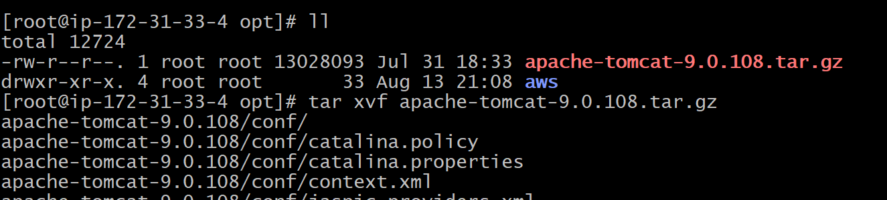

* ll – to list the files
* tar xvf “file name” .gz : to extract the tomcat file.

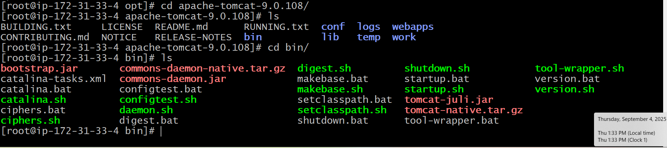

* go to the tomcat directory where it is downloaded : cd “filename”/
* ls – to list the files you can find the configuration files of tomcat.
* Go to bin directory : cd bin/
* Ls - list the files you can find the startup.sh , sh- means shell & .bat is for windows

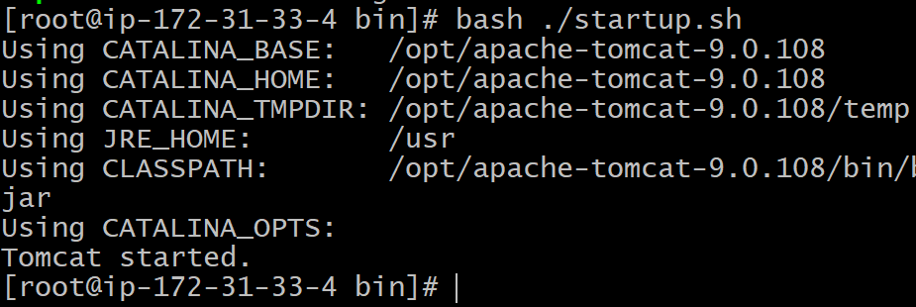

* Startb the tomcat : bash ./startup.sh – to start the service.
* Note : systemctl start cannot be used for every application

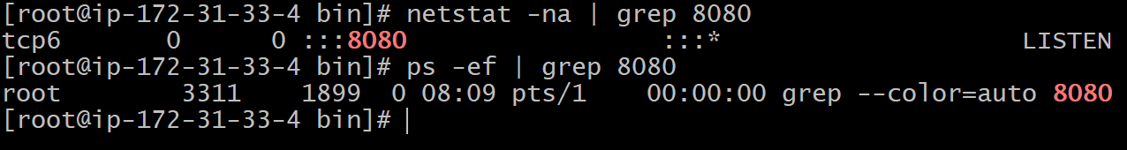

* Check the status using : netstat -na | grep 8080
* Ps -ef | grep 8080 - you see the port 8080 is listening.
* Default log files for tomcat is catlina.out you can see logs.
* Go to web page and enter : “ip “ :8080 – you can see tomcat apache is running on 8080 port



* Fin dthe server.xml file
* Vi server .xml file

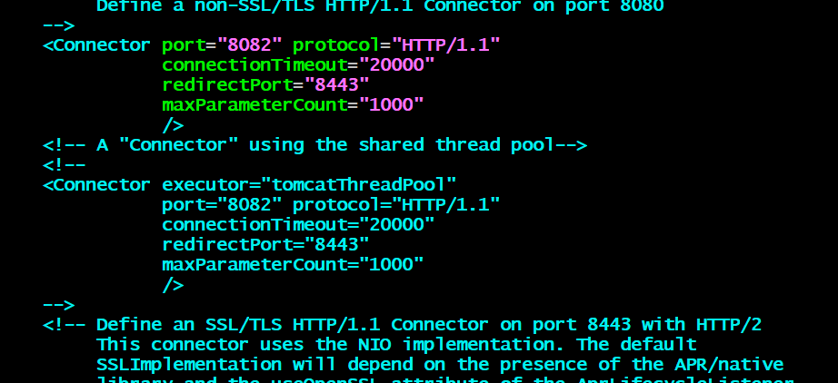

* Change the port to 8082 and save it
* Restart the service and check status
* 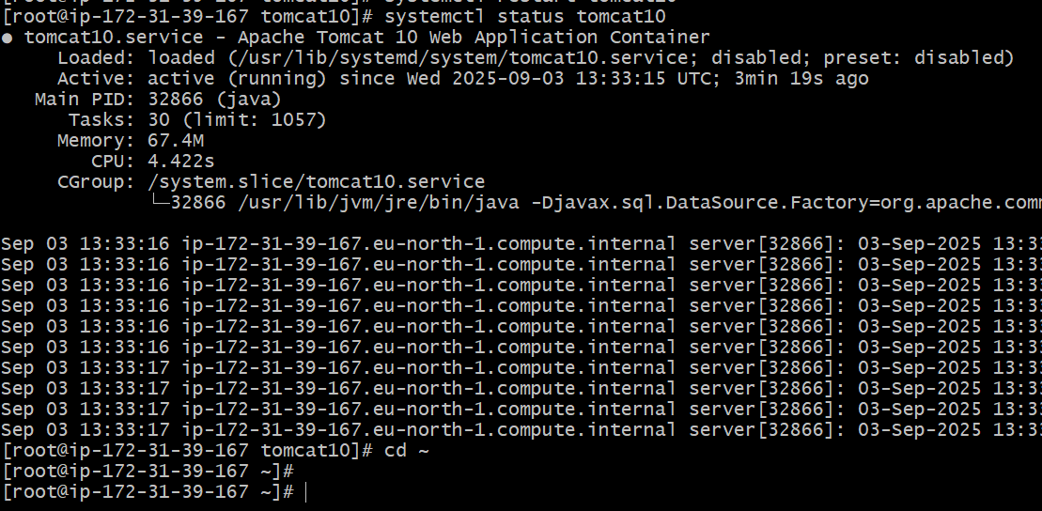
* Got ot web page and enter : “ip address”:8082
* You can see the tomcat apache is running on port8082.

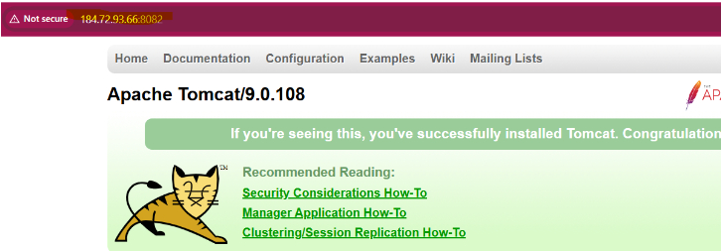

1. DEPLOY SAMPLE APPS ON WEB APPS

* Goto directory /opt/apache_tomat9/webapps
* Download the sample.war that is sample app file
* sample.war file in the directory .
* restart the service : systemctl restart tomcat 9
* Then go to web page an enter : ipadress:80/sample.
* Then you can see the sample app hasbeen deployed.